# INTRODUCTION

* 1. Overview
  2. Dream house (plural dream houses) One's ideal house or home. synonym quotations Synonym: dream home. Used other than figuratively or idiomatically: see dream,‎ house.
  3. Purpose
* Dream Homes is a website created using the Django Framework and a PostgreSQL database.
* It allows users to search for listings using the search tool or by accessing the latest 3 listings which are displayed on the home screen.
* If the user is interested in a property, they are able to send an enquiry to the estate agent who is responsible for that particular property.

1. **Problem Definition & Design Thinking**
   1. Empathy Map

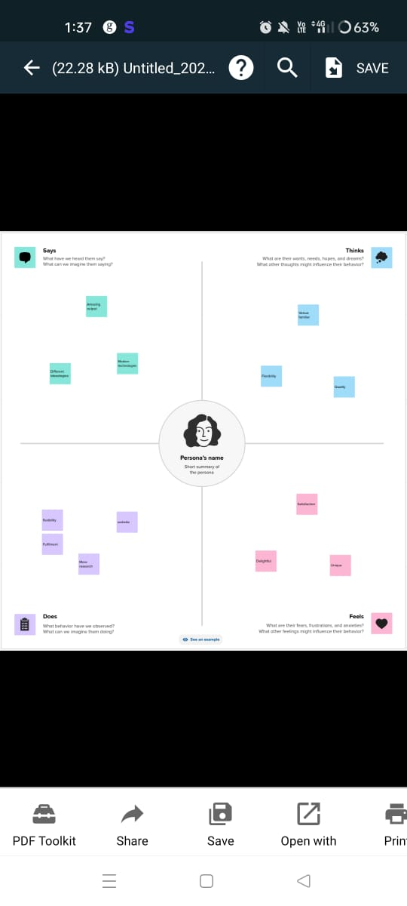

* 1. Ideation & Brainstorming Map

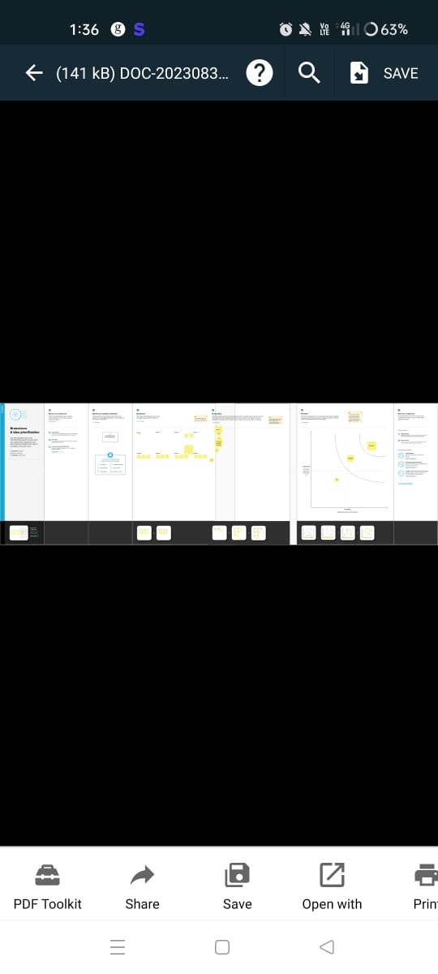

**3 RESULT**

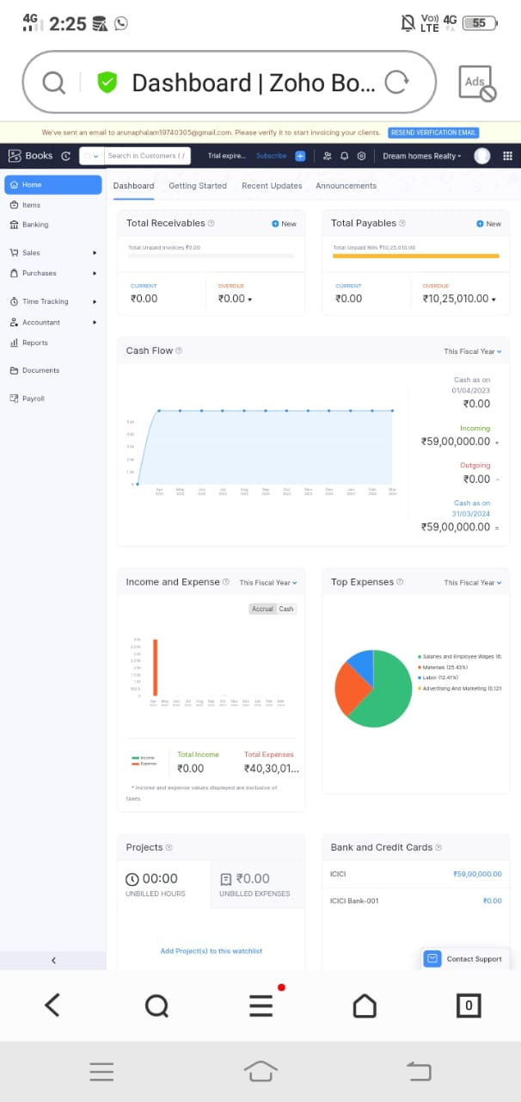

.

# ADVANTAGES & DISADVANTAGES

* Becoming a homeowner is a great investment. ...
* Owning your home gives you some financial security. ...
* Home ownership brings a sense of pride. ...
* Owning a home gives you more freedom than when renting. ...
* You can decorate your property to your liking. ...
* You enjoy more privacy as a homeowner

# APPLICATIONS

# Work is in full swing at Labdhi Gardens, Neral, with new slabs being cast every week. Progress is ahead of schedule and much faster than other projects in the area. Here are a few snaps of the work in progress.

# CONCLUSION

# Are you ready to turn your dream of owning the perfect home into reality? The journey to finding your ideal property can be both exciting and daunting. But fear not! With the right approach and some essential tips, you can navigate the real estate market and find your dream home. In this article, we'll explore the key steps to ensure a successful home search.

# FUTURE SCOPE

Where do you want to live? Research different neighborhoods to find the one that suits your lifestyle. Consider factors like schools, amenities, commute times, and safety. Exploring the area in person can provide valuable insights.